JUnit Testing Exercises

Exercise 1: Setting Up JUnit

Scenario:

You need to set up JUnit in your Java project to start writing unit tests.

Steps:

1. Create a new Java project in your IDE (e.g., IntelliJ IDEA, Eclipse).
2. Add JUnit dependency to your project. If you are using Maven, add the following to your pom.xml:

<dependency>

<groupId>junit</groupId>

<artifactId>junit</artifactId>

<version>4.13.2</version>

<scope>test</scope>

</dependency>

1. Create a new test class in your project.

**Calculator.java:**

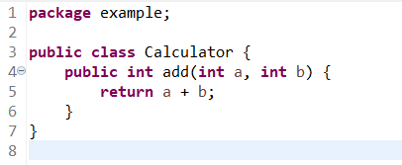

**CalculatorTest.java:**

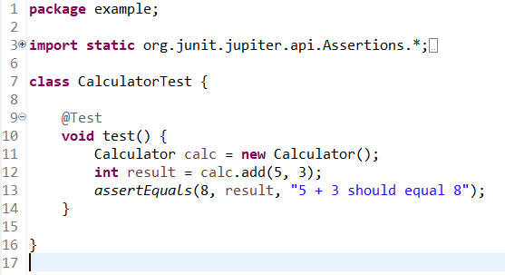

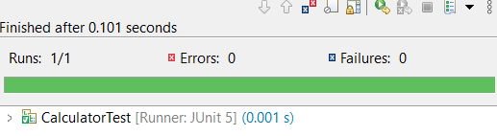

Exercise 2: Writing Basic JUnit Tests

Scenario:

You need to write basic JUnit tests for a simple Java class.

Steps:

1. Create a new Java class with some methods to test.
2. Write JUnit tests for these methods.

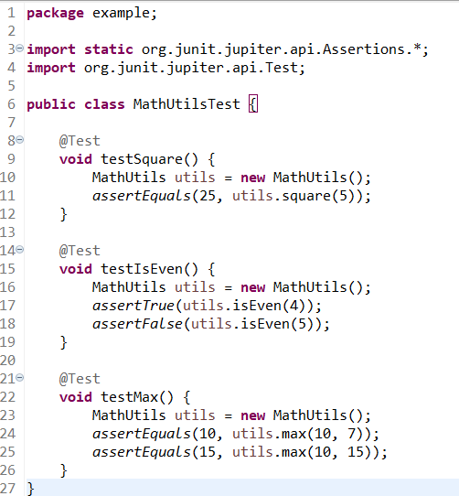

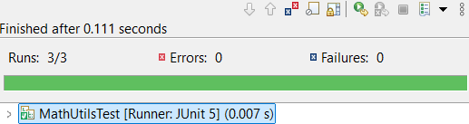

Exercise 3: Assertions in JUnit

Scenario:

You need to use different assertions in JUnit to validate your test results.

Steps:

1. Write tests using various JUnit assertions.

Solution Code:

public class AssertionsTest {

@Test public void testAssertions() {

// Assert equals assertEquals(5, 2 + 3);

// Assert true assertTrue(5 > 3);

// Assert false assertFalse(5 < 3);

// Assert null assertNull(null);

// Assert not null

assertNotNull(new Object());

}

}

**AssertionsTest.java:**

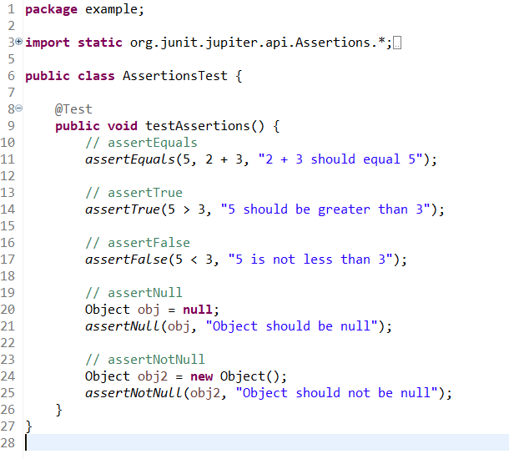

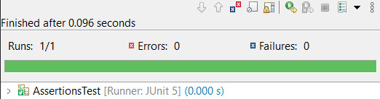

Exercise 4: Arrange-Act-Assert (AAA) Pattern, Test Fixtures, Setup and

Teardown Methods in JUnit

Scenario:

You need to organize your tests using the Arrange-Act-Assert (AAA) pattern and use setup and teardown methods.

Steps:

1. Write tests using the AAA pattern.
2. Use @Before and @After annotations for setup and teardown methods.

